**7.1.2 - The Institution has facilities for alternate sources of energy and energy conservation measures**

**Images**

1. **Solar System (street lights)**

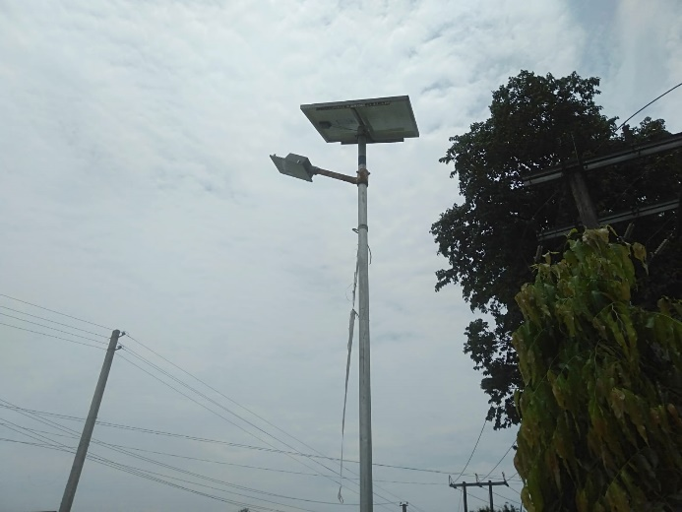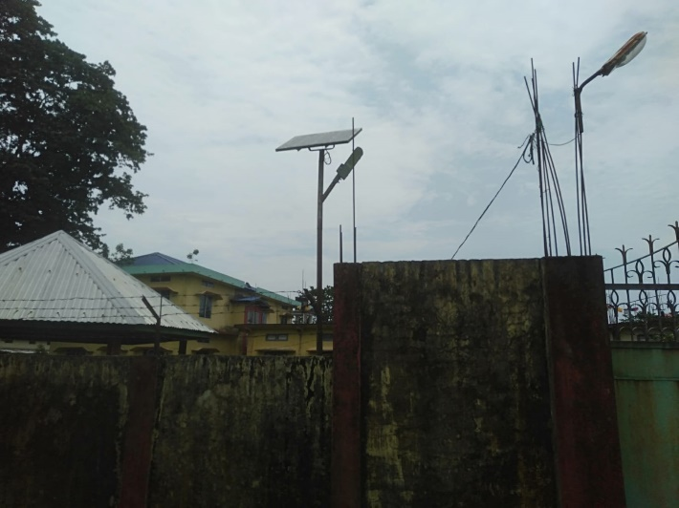

1. **Replaced CRT monitors with LCD and LED monitors**

